DHCP SERVER CONFIGURATION (STEP-BY-STEP)

Purpose of DHCP
DHCP automatically assigns IP addresses to client machines.
Here:
- Ubuntu 1 → DHCP Server
- Ubuntu 2 → DHCP Client

PART A: Ubuntu 1 (DHCP Server Setup)

Step 1: Install DHCP Server
On Ubuntu 1 (192.168.157.128) open terminal and run:
sudo apt update
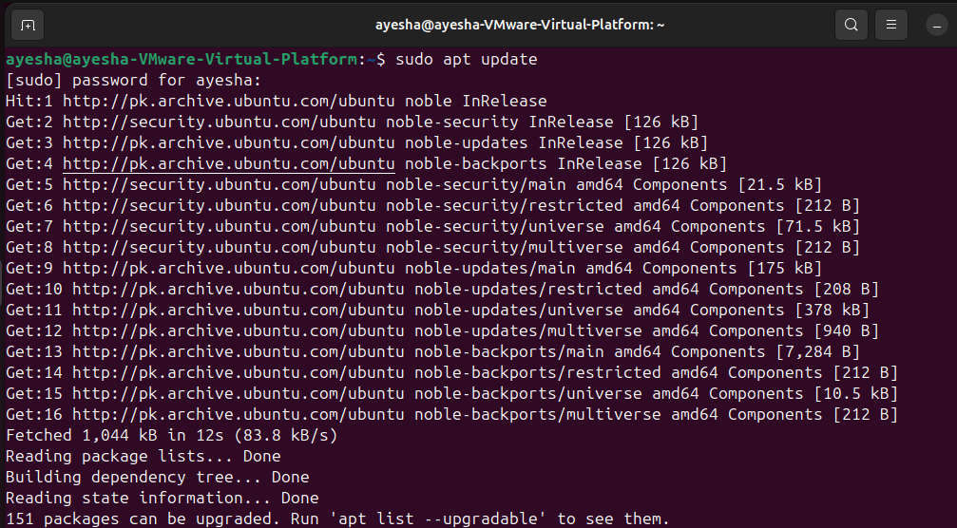
sudo apt install isc-dhcp-server –y
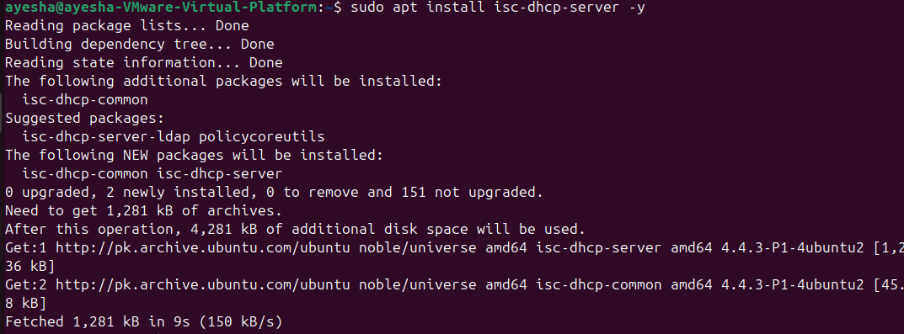
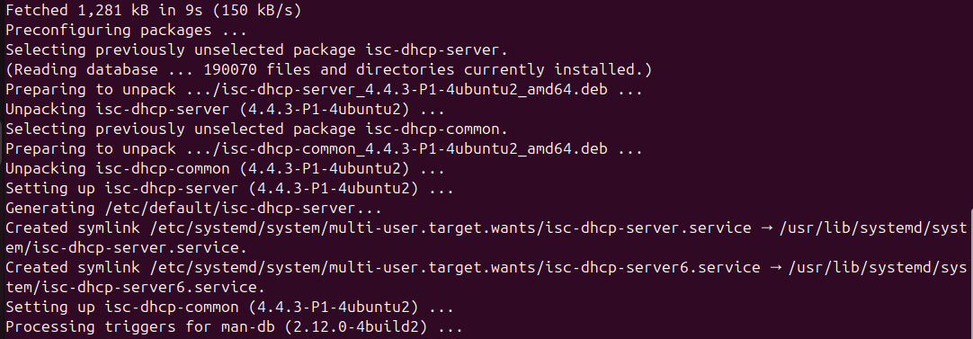
Step 2: Find Your Network Interface
Run : ip a
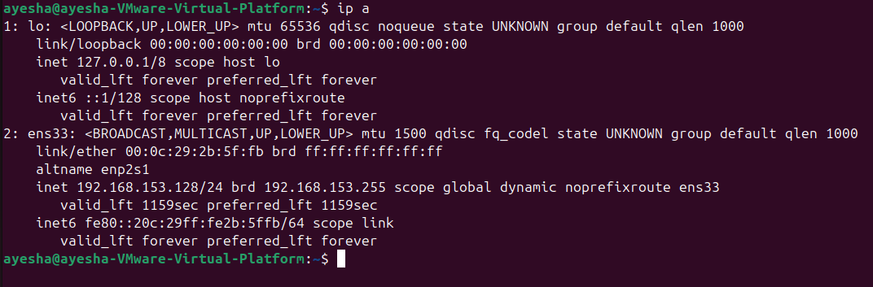
Look for something like:
- ens33 or
- eth0

Step 3: Select Interface for DHCP
Edit DHCP default file:
sudo nano /etc/default/isc-dhcp-server
Find this line:
INTERFACESv4=""
Change it to:
INTERFACESv4="ens33"
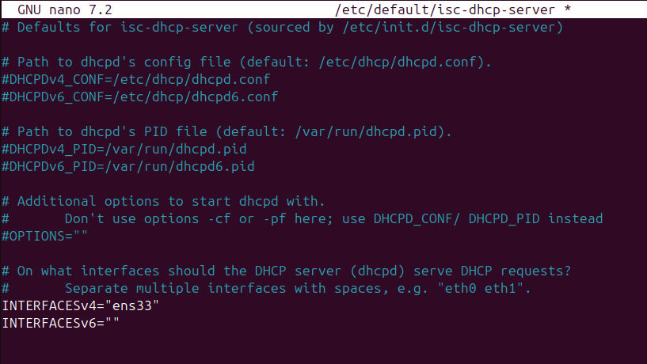

Step 4: Configure DHCP IP Range
Open DHCP config file:
sudo nano /etc/dhcp/dhcpd.conf

Scroll to the bottom and add this (VERY IMPORTANT):
subnet 192.168.157.0 netmask 255.255.255.0 {
range 192.168.157.150 192.168.157.160;
option routers 192.168.157.2;
option domain-name-servers 8.8.8.8;
}
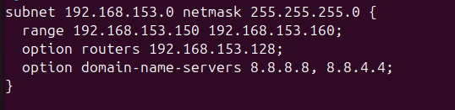

✅ Step 5: Restart DHCP Service
sudo systemctl restart isc-dhcp-server
sudo systemctl status isc-dhcp-server
You should see Active (running)
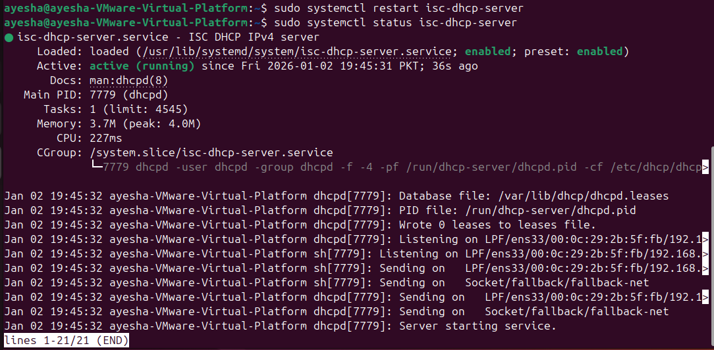

PART B: Ubuntu 2 (DHCP Client Test)

Step 6: Release Old IP (Optional but Recommended)
On Ubuntu 2:
sudo dhclient –v
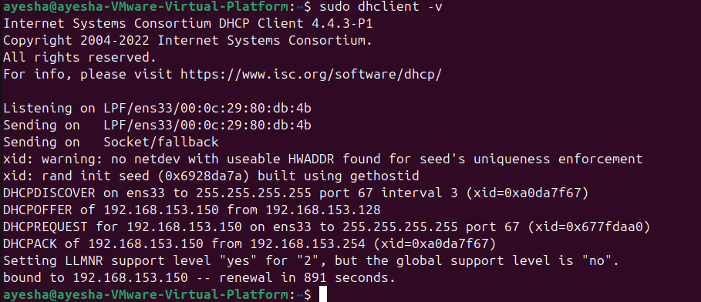

Step 7: Request IP from DHCP Server
sudo dhclient -v
You should see lines like:
DHCPACK from 192.168.153.128

Step 8: Verify Assigned IP
ip a
Ubuntu 2 should now have an IP like:
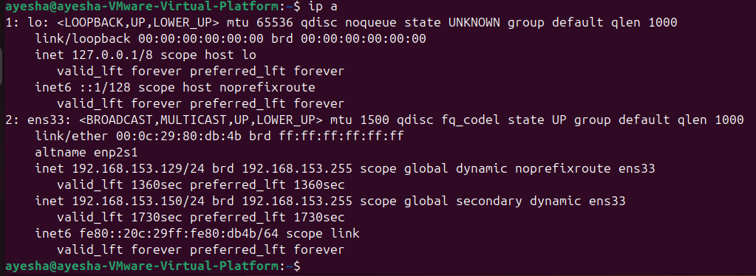

That means DHCP IS WORKING.

PART C: Final Testing (Important)

🔹 Ping Test
From Ubuntu 2:
ping 192.168.153.128
From Ubuntu 1:
ping 192.168.153.150
✔ Ping works → DHCP + Network OK
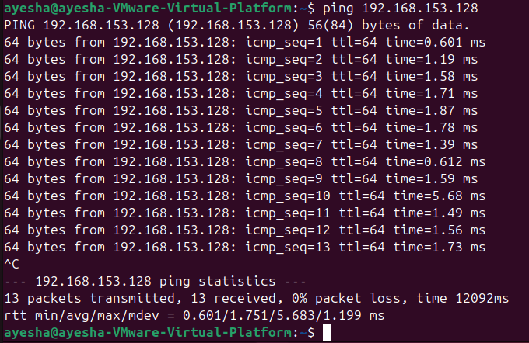
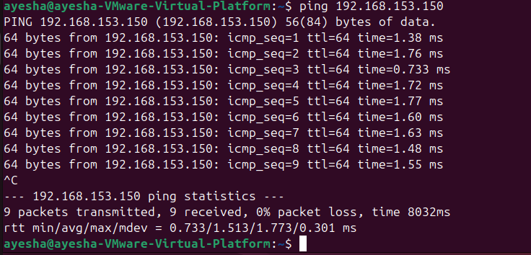

CONCLUSION:
DHCP server was configured on Ubuntu 1 using isc-dhcp-server.
A subnet range was defined, and Ubuntu 2 successfully obtained an IP address dynamically using DHCP.

